Ryan LeChien

Professor DiMarzio

CS-360-R1901

15 October 2023

**Project Three Launch Plan**

**App Description, Permissions. and Icon:** For this project, an event tracking app was developed. This app allows both new and existing users to log in and create, read, and delete events. Upon sign-in, the user is prompted for permission to send SMS push notifications.

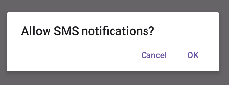

**Figure 1:** The prompt for SMS notification permission

A suitable app icon for this app should indicate that this app deals with keeping track of dates, similar to a calendar. Therefore, a generic calendar icon would be appropriate.



[**Figure 2**](https://cdn-icons-png.flaticon.com/512/8211/8211389.png)**:** The app’s intended icon

**Compatible Versions:** The minimum SDK for this app is API 24, while the compile and target SDK is API 34. This app was developed on an emulated device running API 30. Additionally, the app was tested on an emulated device running API 34, to ensure full compatibility.

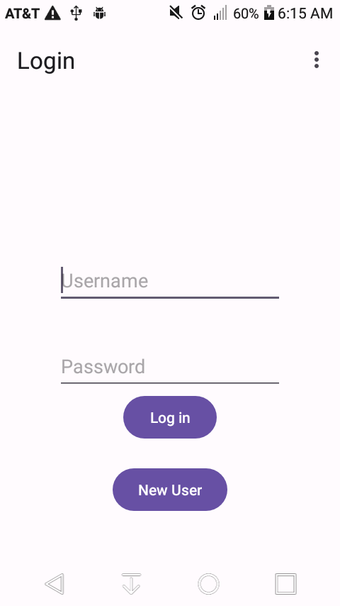

**Figure 3:** Proof of this app running on Android 7 (API 24) (my phone)

**Monetization:** To eventually monetize this app, visual ads may be eventually placed unobtrusively on the bottom of the screen. This source of passive advertisement will help keep the app free for users while also earning a profit for the developer.

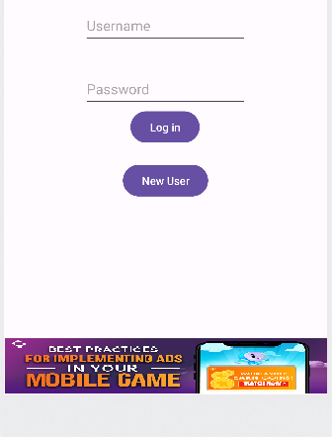

**Figure 4:** Sample in-app ad